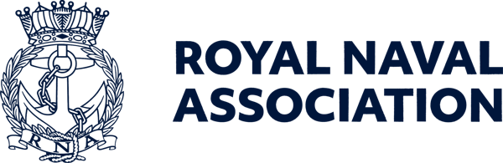

Semaphore Short Friday 16 October 2026



Return to the Falkland Islands

As we approach the 45th anniversary of the Falklands Conflict in 2027, the RNA is exploring the possibility of facilitating a return visit to the Falkland Islands for a group of veterans who served during the Conflict.
We recognise that for many, the Falklands hold profound personal significance. For some, a return may offer an opportunity to reflect, remember, reconnect with old shipmates, and revisit places that shaped their lives. For others, it may not feel right, and we completely understand and respect that.
At this stage, we are simply seeking expressions of interest to help us understand whether there is sufficient appetite for such a commemorative visit.
Alongside the visit, we would also be honoured to preserve Falklands veterans' stories for future generations. With your permission, we would like to record personal recollections and experiences as part of a lasting Falklands 45 legacy project, ensuring that the courage, sacrifice, and service of those involved are never forgotten.
Completing this form does not commit you to travelling or participating in any recording project. It simply helps us assess interest and begin exploring what might be possible.
You can find the form at https://forms.cloud.microsoft/e/chxikApPB6?origin=lprLink

Digital Yearbook option available

You can now choose to go digital with your RNA 2027 Yearbook!
Do you really need a printed copy of the publication? If you don't, please email comms@rnassoc.org and let us know!
If you'd prefer to read it on your phone, tablet or computer, you can opt out of receiving a hard copy and we'll send you a link to the digital edition instead.
It's the same Yearbook, with the same great content which you can read anywhere, anytime, and you will also have done your bit for the planet!
To switch to the digital version, simply email us and we will sort it for you.

Special rates for Shipmates!

And while we are on the subject of the Yearbook, do you have a business or service that you would like to advertise in the publication?
We are putting the 2027 Yearbook together over the next few weeks, and are giving shipmates the opportunity to advertise in its pages at a special rate.
The RNA Yearbook remains our flagship annual publication, distributed to more than 26,000 RNA members, as well as branches, affiliated organisations, supporters, and stakeholders across the wider Naval community.
It provides an excellent platform to showcase products, facilities, services, and ongoing support for the Naval community.
Advertising within the publication offers the opportunity to:
- Raise awareness of your business or service
- Reach a highly engaged audience of serving personnel, veterans, and their families
- Reinforce your relationship with the Naval Service
- Strengthen visibility within a trusted and widely read national publication
A half-page advert in the Yearbook costs just £300, and we are offering RNA members a ten per cent discount on any advertising you take up.
If you would like further information on advertising in our Yearbook, and details of rates for different sizes and placements of adverts, please contact Milly at ceo-ea@rnassoc.org

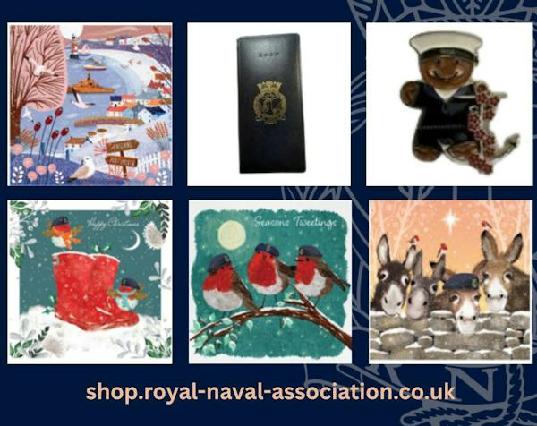

Our shop is back and open for business

We’re delighted to announce that the RNA online shop is back and open for business.
Our popular Christmas cards are available to order now, along with badges, blankets, shirts, ties and other Association items.
More stock and additional products will be added over the coming weeks, so keep your eyes peeled for our new sweatshirts, winter hats and other items.
Our Christmas cards – pictured above – are available in packs of ten at a price of £4.50. There are two designs in each pack – Pack 1 has robins playing on a pair of red boots and a wintry harbour scene; Pack 2 features robins fallen in on a snowy tree branch and donkeys.
Don’t hang about if you would like to order cards as there is a limited amount of stock this year.
Get ready for the festive season and support the Association by visiting the shop today:
https://shop.royal-naval-association.co.uk/

2027 RNA Diaries now on sale

Another item available from our online shop is the 2027 RNA pocket diary, also pictured above.
This slimline diary costs £10 including p&p, and has sold fast in previous years, so get your order in now.
One Shipmate who put his order in early has already received his diary, and the verdict was a resounding endorsement – “Hi – just received my diary. What a great diary, full of information!”
Order your diary via the RNA Online Shop link: https://shop.royal-naval-association.co.uk/

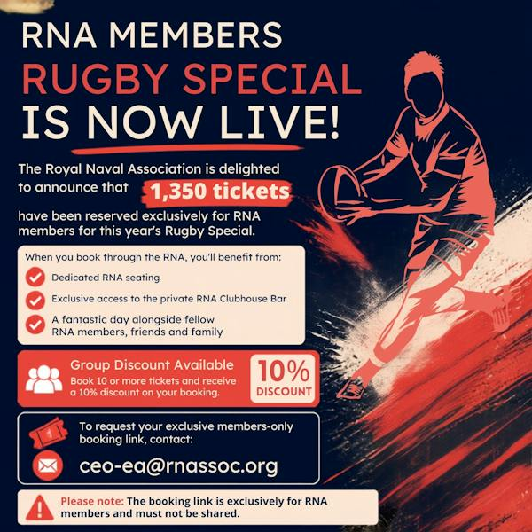

Get your Army v Navy rugby tickets here

RNA members should apply to Central Office for tickets for the Army v Navy rugby matches at Twickenham on Saturday 1 May next year.
The Association has an allocation of 1,350 tickets exclusively reserved for RNA members. For 2027, tickets will be available through a dedicated
members-only booking link, which will be sent directly to members who request tickets.
Please note: To protect our allocation, this booking link must remain confidential and must not be shared with anyone else.
The RNA experience provides:
- A dedicated RNA seating
- Exclusive access to our private clubhouse bar.
Enjoy the day alongside fellow RNA members, friends and family.
The rugby kicks off at 1400 with the senior men’s clash, with the women’s match following at 1645.
If you are bringing a crowd with you, purchasers of ten or more tickets will receive a ten per cent discount on their booking.
Contact us to request your members-only booking link and secure your place before our allocation is exhausted.
Email Milly on ceo-ea@rnassoc.org

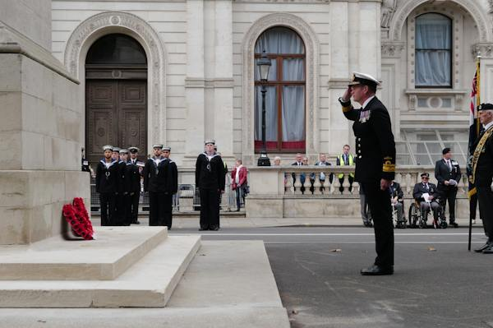

Remembrance and Comradeship Grants

Could your RNA Branch benefit from funding for a remembrance or comradeship activity?
Royal Navy & Royal Marines Charity (RNRMC) Remembrance and Comradeship Grants can help eligible RNA Branches and other Naval and Marines organisations fund activities that bring people together, support remembrance and strengthen comradeship, while helping to reduce loneliness and social isolation.
Funding can contribute towards:
* Remembrance and commemorative events
* Travel to national remembrance events
* Branch and community gatherings
* Venue hire, refreshments and promotion.
Your application should explain how the activity will benefit your community and help people connect with others and access support.
Find out more and apply: https://www.rnrmc.org.uk/remembrancegrants.

Keeping in touch with Central Office

While maintenance work is being carried out on Lanyard House the Central Office staff are working from a temporary office space.
During the time that we are away from our usual office, we don’t have access to the old phone or voicemails.
If you need to reach us, please use the Office Mobile on 07889 059025, or use our usual email addresses, which are still working normally.

  Shop for the Association
  You could turn your everyday shopping into support for the RNA without spending an extra penny.
  Whether you're buying gifts, booking a holiday, or ordering your weekly essentials online, you could be raising free donations for the Royal Naval Association through easyfundraising.
  Simply sign up, select the RNA as your chosen charity, and participating retailers will donate on your behalf at no additional cost to you.
  It’s free to join, there are thousands
  

of retailers involved, and every donation helps support members, veterans, and their families
Start fundraising the easy way – use this link: https://tinyurl.com/54b34d42 or use the QR code (above right). You just need to click ‘Support this Cause’, create a free account, and start shopping with participating retailers via the website, app or browser extension.
Once you’re registered, donations will be automatically generated whenever you make eligible purchases.

 |  |  |  |  |  |  |  |  |  |  | 

